Project Design Phase-II
Customer Journey Map
Date | 04 October 2026
Team ID | SWTID-2026-6870
Project Name | Streamlining IT Procurement: Automating Standard Laptop Orders with Flow Designer
Maximum Marks | 4 Marks

Customer Journey Map
The journey map follows an employee who needs a standard laptop, from raising the request to the laptop being configured by the Hardware team. It uses the five stages Entice, Enter, Engage, Exit and Extend.
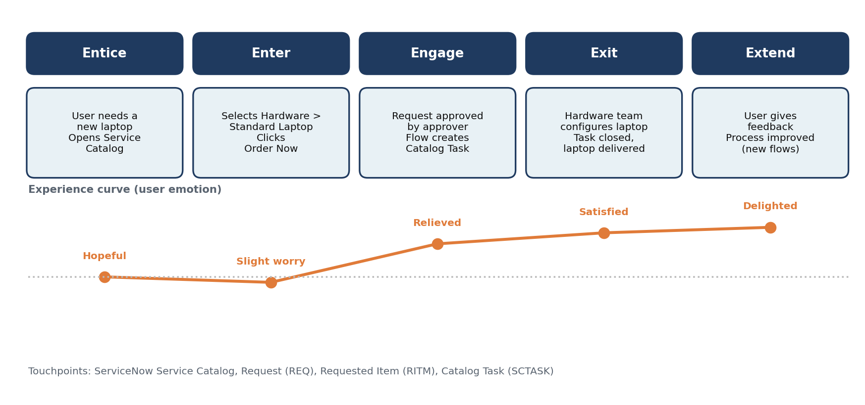
Figure 1: Customer journey for a Standard Laptop request
Stage | What the user does | Touchpoint | Emotion | Opportunity
Entice | Realises a new laptop is needed and opens the Service Catalog | ServiceNow home / Service Catalog | Hopeful | Make the Hardware category easy to find
Enter | Opens Hardware > Standard Laptop and clicks Order Now | Catalog item page, Order Status page | Slightly worried | Confirm submission clearly (request number shown)
Engage | Approver approves; the flow creates the catalog task for Hardware | Request, Requested Item, Catalog Task | Relieved | Automate task creation so nothing is missed
Exit | Hardware team configures the laptop and closes the task | Catalog Task form | Satisfied | Keep short description clear for the technician
Extend | User gives feedback; team adds more automations | Feedback, future flows | Delighted | Extend automation to other catalog items

